Tun Yuh Hand Mek Fashion: A Clothing Collection
Grayson Chong

“Tun Yuh Hand Mek Fashion: Dancehall Fashion as Everyday Resistance in Jamaica and the Caribbean Diaspora” is a dissertation project that analyzes how women use elements of Jamaican dancehall fashion to protest intersectional inequalities of racism, classism, sexism, etc. More specifically, I argue that Jamaican dancehall fashion is a historical palimpsest that speaks to women’s resistance, their self-fashioning, and the formation of social networks and labours of care. To do so, I engage in close readings of novels by Margaret Cezair Thompson (1999), Oonya Kempadoo (2013), Earl Lovelace (1979), Patricia Powell (1998), and Zalika Reid-Benta (2023); films such as Dancehall Queen (1997); and music videos of dancehall artists such as Spice (2017) and Shenseea (2018; 2025). Throughout the dissertation, I focus on dancehall fashion as a site of everyday resistance and creation for women. I take on Carol Tulloch’s idea that dancehall clothing is a “form of freedom [and] self-invention.”
In this project, the Jamaican saying, “Tun yuh hand mek fashion” becomes concept, theory, and practice. “Tun yuh hand mek fashion” refers to the ability to take what you have and turn it into something new. It speaks to resistances of the everyday because it focuses on innovation and resourcefulness to create something out of necessity. I employ the expression “tun yuh hand mek fashion” by literally making fashion (designing and constructing garments) out of old pieces of clothing and fabric and transforming them into something new or different. This reflects women using clothes (either buying new clothing or repurposing clothes they already have) to transform their identities into personas that they present in the dancehall space. In an effort to stay true to the phrase, I recycle fabric that is available to me from clothing I no longer wear. As a result, using textiles and fabric as my main method of artmaking pushes me to think about the importance of sustainability. What transpires from “tun yuh hand mek fashion” as a practice are multiple garments that culminates into a clothing collection. Each garment showcased in this collection reflects how elements and aesthetics of Caribbean celebrations of resistance that originated in the 17th and 18th centuries (eg. Jonkonnu, Carnival, etc.) are still prevalent in dancehall fashion. By combining literature and design practice together, my work advocates for public-facing scholarship and expands ideas of what scholarship can be and the forms it can take.
In Crafted Kinship: Inside the Creative Practices of Contemporary Black Caribbean Makers (2024), Malene Barnett notes numerous common threads and themes that bind Caribbean artists together. My own garments engage with the themes outlined by Barnett such as ancestors; colonial histories; identity; joy; memory; and spirituality. In doing so, my work finds itself in conversation with other Caribbean artists featured in Crafted Kinship such as Firelei Báez; Andrea Chung; Deborah Jack; Fabiola Jean-Louis; Althea McNish; and Juana Valdés.

The collection is currently on view in the South College lobby (3rd floor) at the University of Massachusetts Amherst until the end of May.

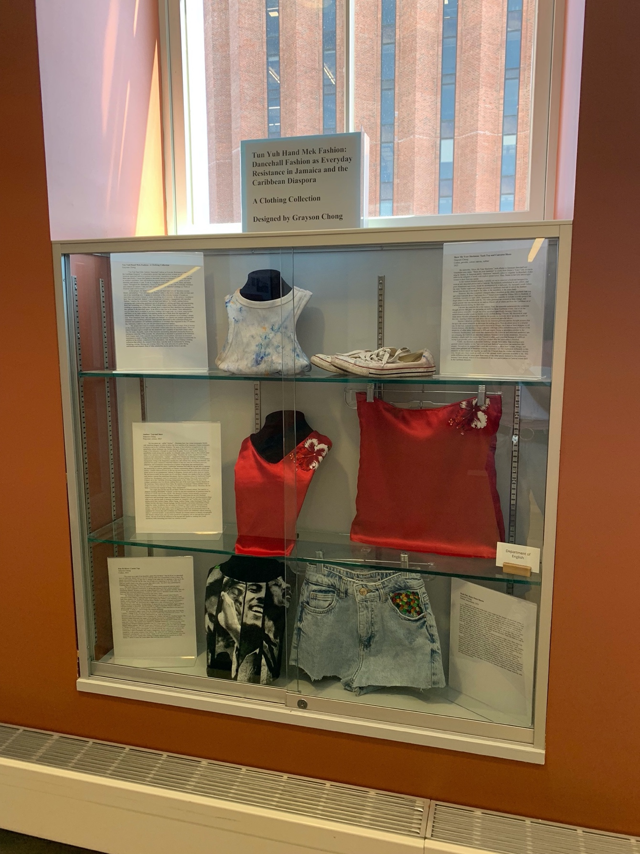
Grayson Chong, Tun Yuh Hand Mek Fashion: A Clothing Collection, South College, University of Massachusetts Amherst, April 22, 2025.

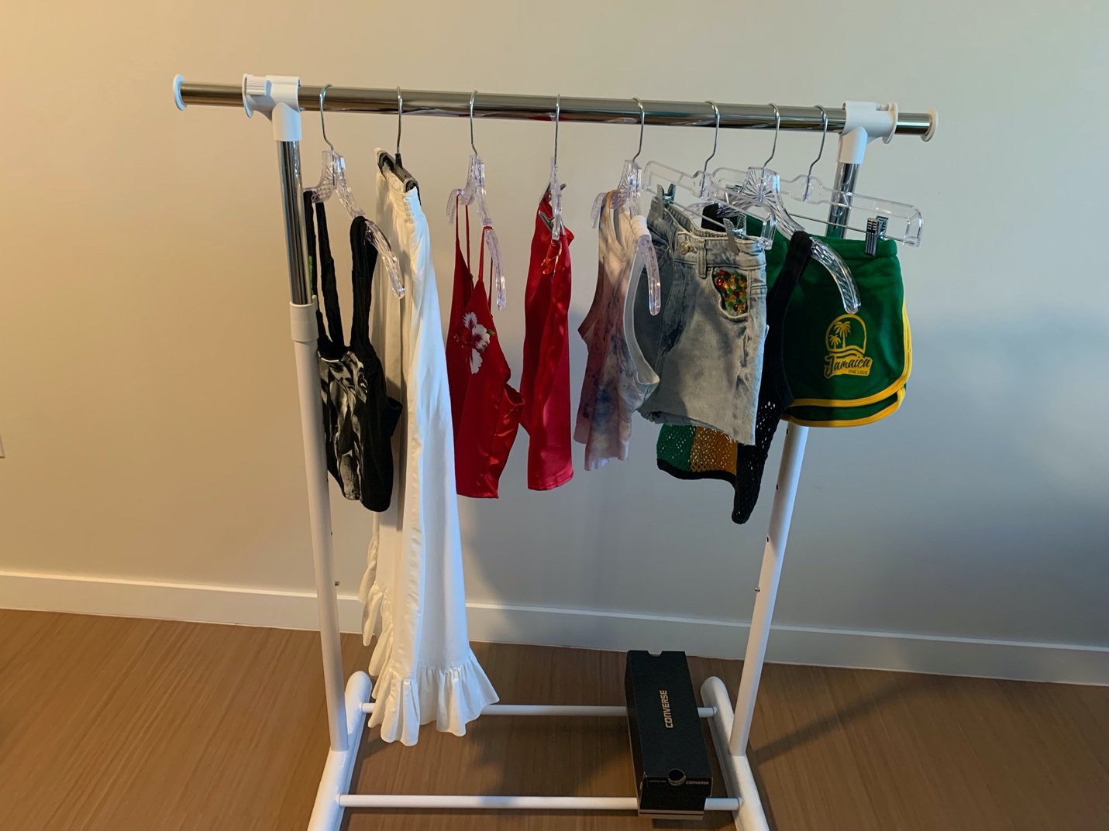
Grayson Chong, Tun Yuh Hand Mek Fashion: A Clothing Collection, 2025.

Anchor: Top and Skirt
Grayson Chong
Polyester, cotton, 2025

My two-piece set – called “Anchor” – illustrates how East Asian iconography blends with Jamaican imagery in order to reflect the lived realities of the Jamaican-Chinese community in Jamaica and in the Caribbean diaspora. The name of the collection is inspired by my late grandfather whose nickname was Anchor among his friends and customers in Jamaica. The origin of his nickname is thought to come from the game, “Crown and Anchor” because my grandfather would always bet on anchor. In a broader sense, anchor refers to ship anchors since many of my ancestors came to Jamaica on ships. Therefore, the anchor signifies them being rooted in a new place/nation. “Anchor” – inspired by Chinese and Jamaican iconography– emphasize the complexity of Jamaican Chinese identity especially as it relates to transmigrancy; immigration; living in the diaspora(s); kinship ties; and cultural loss, mixing, and retention. The patterned two-piece connects to dancehall fashion in that they both are invested in survival, adaptation, and (sometimes) reconstruction of places of belonging and communit(ites).
In my patterned two-piece, I embroider Jamaican flora onto the top and skirt to represent the intermixing of cultures, particularly as Chinese communities adapt to Jamaican culture and society. I feature hibiscus flowers on the top and skirt because they symbolize the red hibiscus plants grown on my grandparents’ balcony in Kingston, Jamaica and on their decks in Canada. My decision to create the two-piece out of a red dress I already own speaks to the tun yuh hand mek fashion concept that underlines this project. Red is a common colour for traditional Chinese clothing (eg. cheongsams) since it is associated with good fortune. Due to the mass exodus of Chinese out of the Caribbean following Independence of the 1960s and 1970s, most of the younger generation now live abroad, making them part of the much larger Chinese diaspora in the Americas. Thrice removed from China, the majority of Jamaican Chinese children born in North America or the UK have very little ties to their Chinese Hakka culture. Therefore, the red fabric symbolizes the tensions of being “thrice diasporized”.
One might miss the fact that the red fabric alludes to Chinese culture. The inability to pinpoint anything identifiably “Chinese” on this top and skirt reminds me of questions posed by Lok Siu in Circles and Circuits (2018): “Do diasporic Chinese viewers assume a common, shared experience with diasporic Chinese subjects? To what extent do our own localized experiences and knowledge shape our interpretative frames? How do our viewing practices shape what we see, and the kinds of meaning we bestow on ‘diasporic’ art?” In this way, I find myself among artists like Carlisle Chang, Albert Chong, Andrea Chung, Liang Domínguez Fung, and Althea McNish who have Chinese heritage, but this element is not always identifiable in their respective works. In addition, the red relates to Glissant’s “right to opacity” because on the surface, it seems that the red fabric is used because it is the same colour as the red hibiscus flowers. The use of red fabric adds a layer of significance that does not necessarily need to be explained but ensures that both Caribbean and Chinese cultures are celebrated without reducing them to “universal models” as described by Glissant. In a human instinct to identify recognizable and familiar cultural signs, this top raises questions of engaging with art through place-specific lenses. The use of red and the hibiscus on the top and skirt speaks to creating new visual narratives while illustrating how these two cultures co-exist.

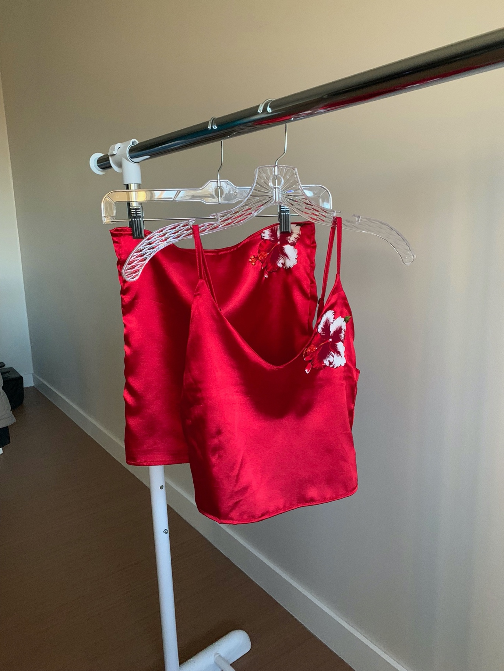
Grayson Chong, “Anchor: Top and Skirt,” polyester, cotton, 2025.

Show Me Your Slackness: Tank Top and Converse Shoes
Grayson Chong
Cotton, powder, cotton canvas, rubber
2025

My ensemble, “Show Me Your Slackness,” both alludes to Jamaican dancehall and Trinidadian soca music. “Show me your slackness” is a lyric from Destra’s “Lucy” (my favourite song by Destra). In Jamaican patois, “slackness” basically refers to vulgarity. In dancehall, it also refers to the subgenre of music with explicit sexual lyrics. Thus, Destra in her lyric encourages women to show their sex appeal.
In this fashion-focused project, I initially set out to construct a bodysuit because it is worn at both dancehall parties and at Carnival. The bodysuit, embellished in red, yellow, and green rhinestones and jewels, would be accompanied by a backpack. My backpack would follow the same “feather explosions” design prevalent in Caribbean festivals in which the feathers spread from the top of the head to the sides, to the shoulders, to the entire body.
However, this idea completely changed when I stumbled on the white racerback tank top and white Converse shoes I had worn for a J’Ouvert event hosted by UMass SOCA (Students of Caribbean Ancestry) in April 2024. I purposely kept the ensemble to include it in this project but forgot about it as the months went by. The white garments are covered in blue, orange, and purple powder that was thrown on me and my friends (all of whom are from the Caribbean or of Caribbean descent) during the festivities.
I include the ensemble for a few reasons. First, the ensemble underscores the conscious thought process that goes into preparing an outfit for these Caribbean events. Out of all the colour options available, I bought the white racerback specifically because I knew that multicoloured powder would be thrown on my clothes during J’Ouvert. My decision to wear white shoes was also influenced by wanting the powder to distinctly show up on my outfit. In this way, wearing a white tank and shoes was an intentional sartorial choice.
Second, I detail my previous ideas for the featured garments and the thought process that led up to the current ensemble to showcase the scaling down from an ornate piece to a simpler one. In this way, I mimic a similar creative decision as Slinger, the Carnival band designer in All Decent Animals, who decides to forgo costumes with high-affect embellishments in favour of the simplicity of white fabric (fashioned in different ways). Doing so provides a counter to the ornateness, flamboyancy, and excess that characterizes the Carnival and dancehall aesthetic.I am not critiquing the Carnival and dancehall aesthetic because I revel in the ornateness. However, donning a simple outfit for events like J’Ouvert is often more practical because it’s difficult trying to get powder, paint, and mud off your clothes after the celebration is finished.
Finally, my decision to showcase clothing I already have rather than creating a new garment entirely touches on the “tun yuh hand mek fashion” expression that underlines this project. Throughout the project I have used this expression to show how I create, design, and make a new garment out of discarded clothing. However, I use this expression differently in this ensemble in that I simply put together an outfit for J’Ouvert from the clothes and shoes I already own. Simply put, I have made an outfit out of the (already made) garments available to me. This subtle difference sets this piece apart from many of the other pieces featured in this collection because I have already worn it. It is a testament of my own participation in Carnival events held in the Caribbean diaspora.

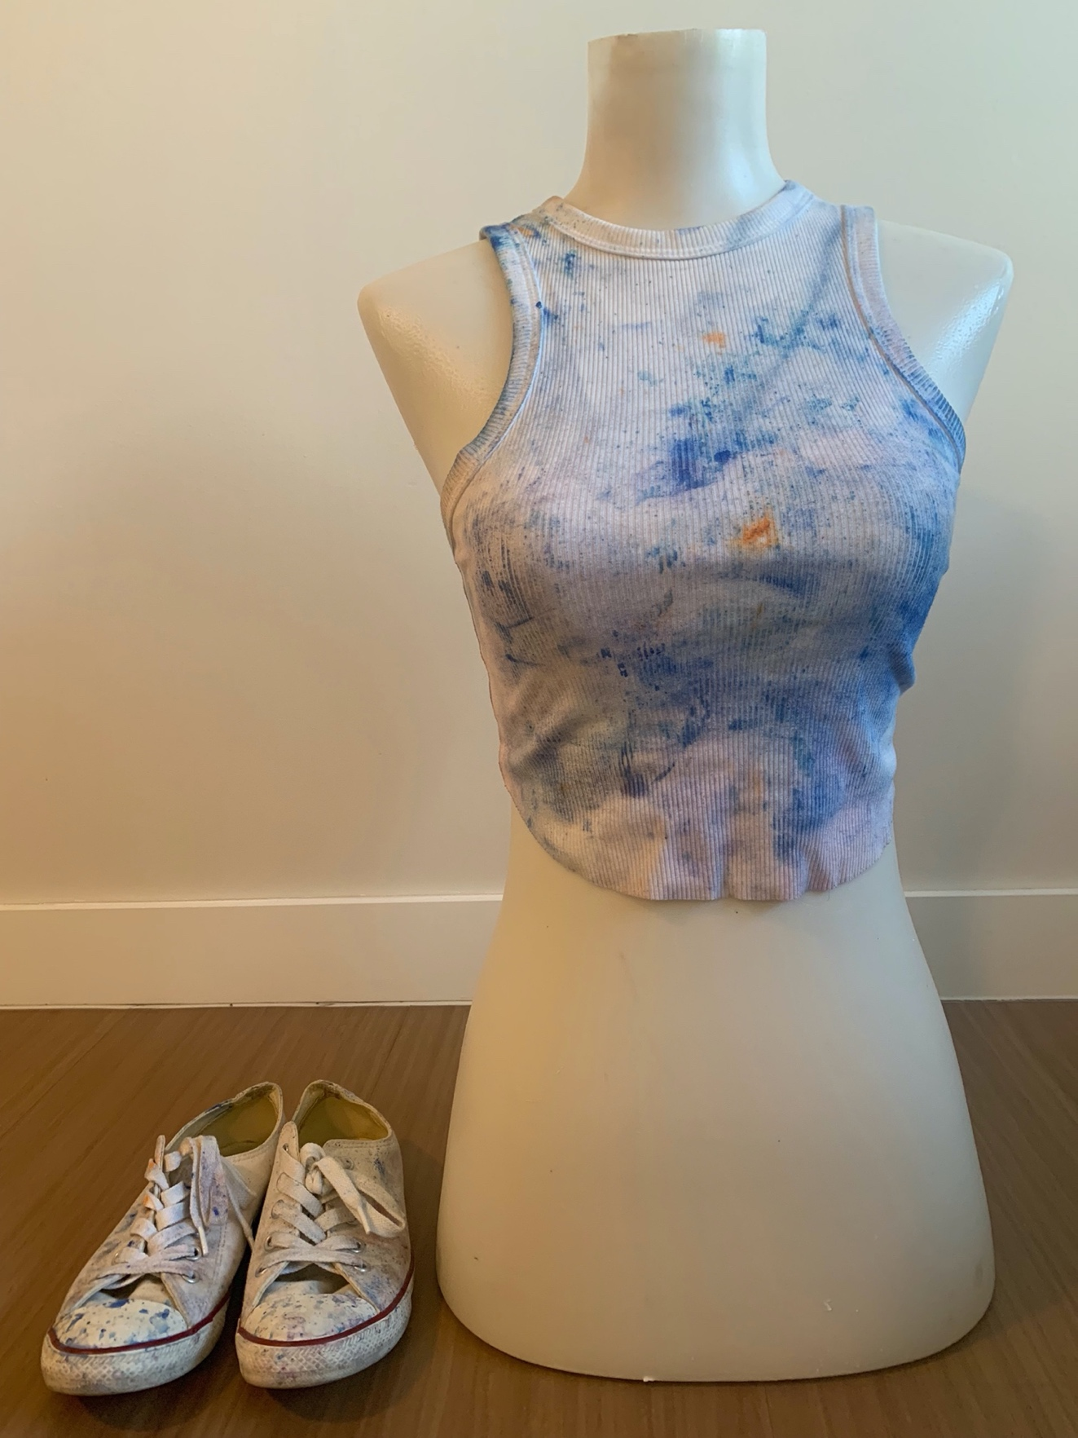
Grayson Chong, “Show Me Your Slackness: Tank Top and Converse Shoes,” cotton, powder, cotton canvas, rubber, 2025.

Dash Out: Batty Rider Shorts
Grayson Chong
Denim, rhinestones, 2025

“Dash Out” is the name of the batty rider I made for this chapter. In dancehall parties, it is very common for the DJ selector to say, “Dash out!” “Dash out” is a call to action. You “dash out” when your song comes on and it is time for you to embody your main character energy. In Out There Without Fear (2020), a documentary about dancehall, Maria Hitchins explains how the “dash out” call inspires action in women in the dancehall: “if we look at the selector who says, ‘Gyal segment time. Dash out!’ And the women comply, they get to the middle, the center circle, the video light is on, and they’re on the head tops, and they spread out.” My title also alludes to the song called “Dash Out” by dancehall artiste, Tifa. In it, she sings: “Cause me just want dash out when me hear me song play / Bubble up and me body / Dash out when me hear da song deh / Bend over. Weh the hell me man deh?”
In this fashion-focused project, I have decided to construct a batty rider. Batty riders are shorts where the cut is right at the butt cheeks so that the crevices of the women’s butt are showing. Batty riders go by various names such as “knockout shorts,” “bum riders,” and “concha shorts.” In Dressed in Dreams (2019), Tanisha C. Ford observes that wearing batty riders is “a shared cultural language” among Black women. I chose to make a batty rider because they are a staple piece of clothing in dancehall fashion (and Caribbean fashion more broadly).
The batty riders I construct are made from my own jeans. I did so by cutting the legs of my old jeans to make them into denim shorts. This act (and visual) of cutting and slashing clothing is common in dancehall fashion aesthetics. I embellish parts of the batty riders with green, yellow, and red rhinestones. I chose the colours to pay homage to the cultural and spiritual significance that red, green, and yellow hold in Rastafarianism. These colours are also ubiquitous in Jamaican fashion. I use rhinestones to allude to the bling-bling aesthetic prevalent in dancehall fashion. The bling-bling aesthetic refers to wearing big, flashy jewellery and clothing to indicate status and wealth. It usually results in a maximalist fashion look. Dancehall artists such as Popcaan, Rihanna, Shenseea, and Spice are known for wearing outfits that engage explicitly with the bling-bling aesthetic.

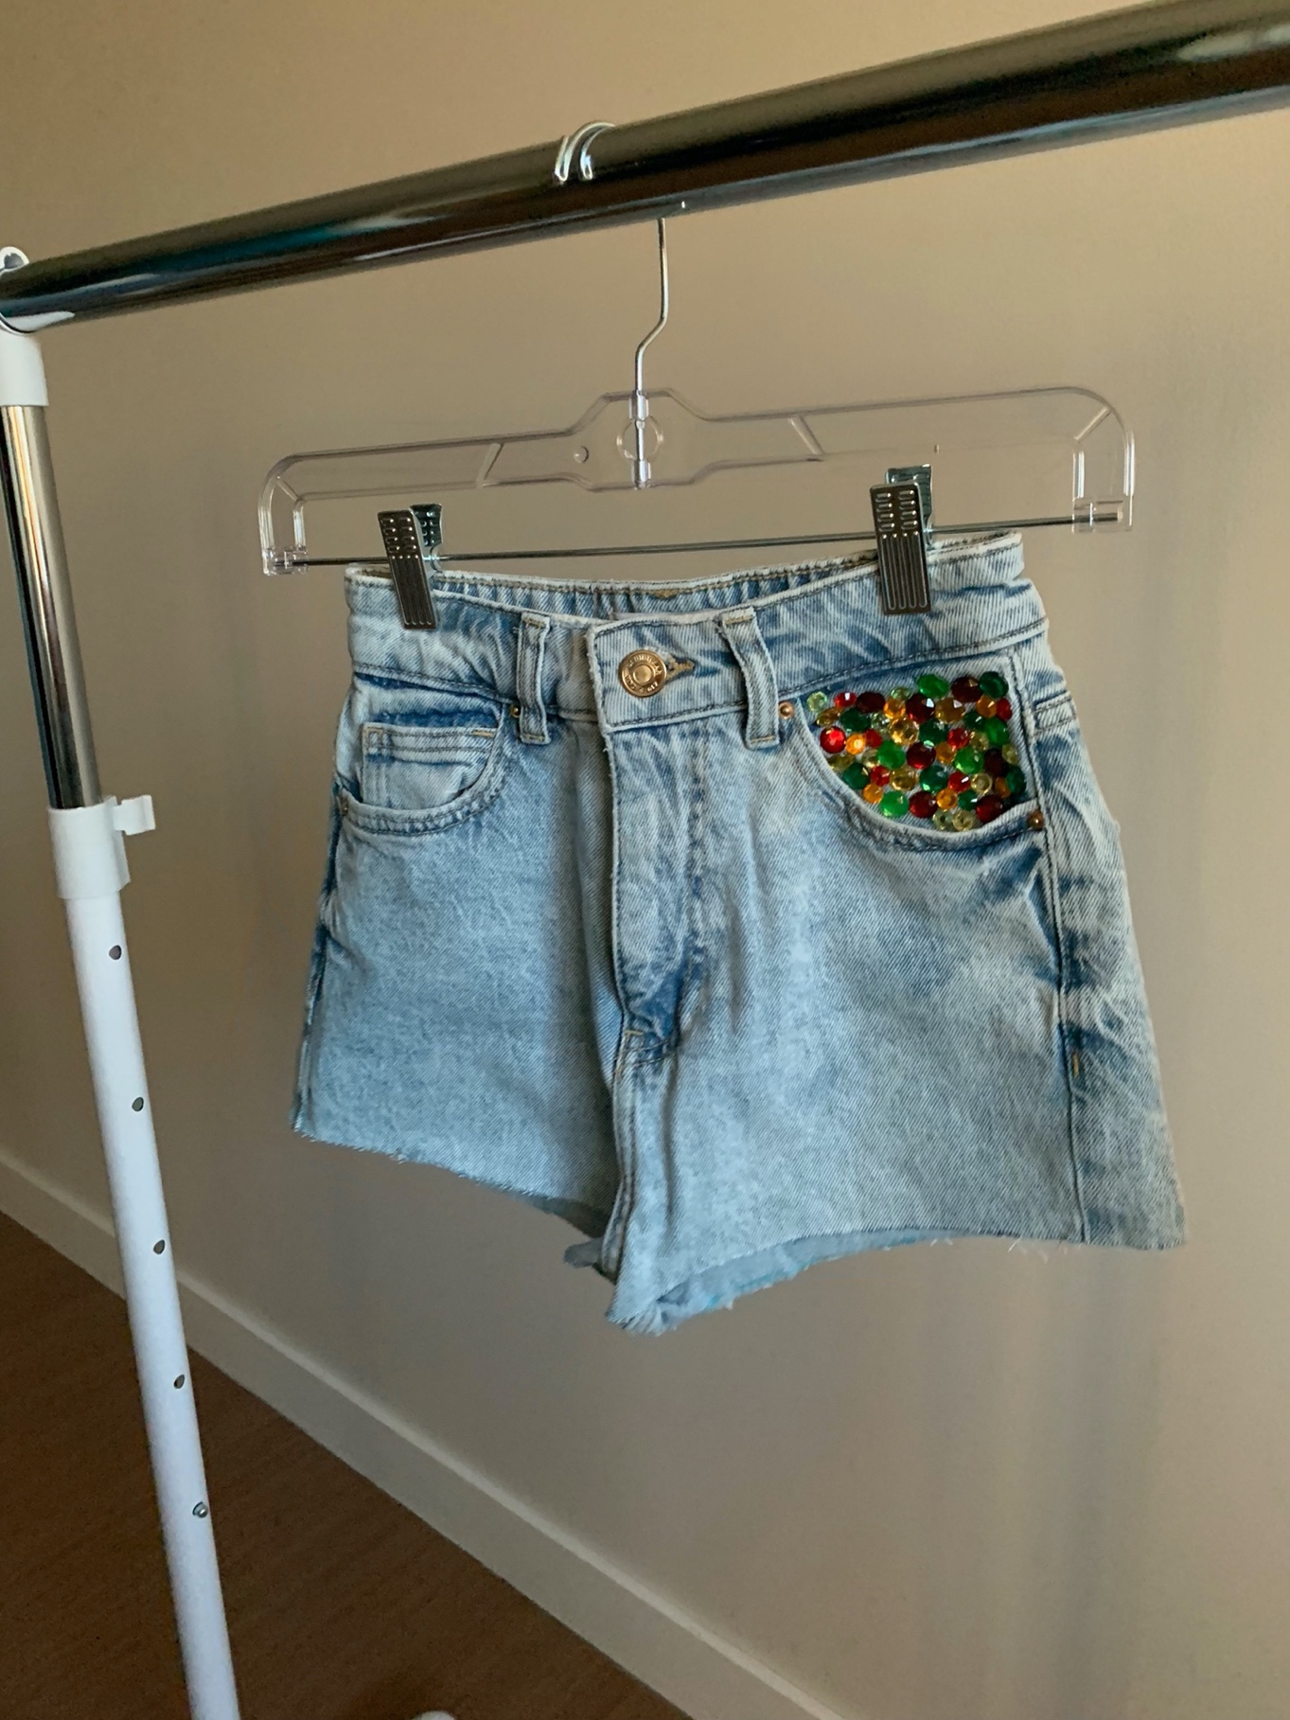
Grayson Chong, “Dash Out: Batty Rider Shorts,” denim, rhinestones, 2025.

Pon Di River: Corset Top and Skirt
Grayson Chong
Cotton, 2025

This corset top and skirt ensemble is called “Pon Di River.” Pon Di River is a dancehall move in which the dancer hops on one foot with the other foot outstretched in front of them; the dancer will continue to hop on that foot or change to the other foot. In variations of the move, the dancer will hop on foot and use the other foot to kick over (repeating on the other side). The arms are usually close to the sides or swing from side to side. The move was popularized by Elephant Man in his song, “Pon Di River” (2007).
The corset idea comes from my history of making corsets alongside seminar papers during my time in graduate coursework. In spring and summer of 2024, corsets trended in mainstream fashion. Modern corsets are being redesigned to allow for greater mobility while still retaining their structured appearance. Corsets are often worn by dancehall female artists, like Spice and Shenseea, during live performances and music videos.
My decision to make a corset from Bob Marley T-shirts occurred when I found a collection of Bob Marley T-shirts that my grandparents have given me every time they come back from Jamaica over the past ten years. Upon finding the T-shirts, I was reminded of the Bob Marley medley playing before the National Dance Theatre Company of Jamaica (NDTC) performance I had seen in June 2023. My decision to use a reggae icon is also influenced by the NDTC’s reggae homage to Rita Marley. On the surface, it seems odd for me to highlight reggae artists in a project focused on dancehall. But this homage to reggae is important because both music genres originated as forms of musical protest. In fact, reggae is often described as the precursor to dancehall. In doing so, I acknowledge this musical genealogy.
By choosing to make a corset from the clothing I already have (in this case, Bob Marley T-shirts), I engage in the “tun yuh hand mek fashion” method that underlines this project. This decision to use the T-shirts is further influenced by my work on Rendering Revolution/Revolisyon toupatou with co-curators, Dr. Siobhan Meï and Dr. Jonathan Square. The bilingual exhibit showcases the impact of the Haitian Revolution on contemporary art and fashion. One of works on display are photographs printed onto second-hand clothing such as jeans and T-shirts. The curators were inspired by Charlotte Hammond’s research on pèpè (used clothing from Western countries (typically from the United States) that has decimated the Haitian fashion industry. Meï and Square print Hammond’s photographs onto their own clothing to “bridge academic inquiry with artistic practice, positioning both as essential tools for critical reflection. By printing these photographs on our old clothing, the work not only celebrates the collaborative spirit of academic and creative engagement, but also underscores our shared complicity in the global systems of fast fashion.” By using their own clothing as material for Hammond’s photographs, Meï and Square engage in the “tun yuh hand mek fashion” ethos that underlines this project. Seeing their clothing on display influenced my decision to use Bob Marley T-shirts to create the corset rather than sourcing fabric elsewhere.
I initially envisioned that I would make a linen skirt inspired by two performances that I witnessed by NDTC: “Rita Marley Tribute” (2022) and “Gerrehbenta” (1979). During “Rita Marley Tribute,” the women wore white A-line skirts with red, yellow, and green trim at the bottom. The colours represent Rastafarian religion adding to how spirituality finds itself embedded in Jamaican performances.
My idea to construct a skirt changed when perusing through my grandmother’s racks of clothing. I found an asymmetrical white skirt with a ruffled hem. My grandmother brought it with her from Jamaica to Canada. With her permission, I have included it in this collection. I decided against altering it because the sentimental value attached to it.
The skirt also reminds me of two Jamaican cultural clothing pieces: 1) the bandana skirt which is part of the national costume and 2) white skirts worn during Kumina celebrations. The bandana skirt is one part of Jamaica’s national costume which was developed by Beth Lenworth Forbes in 1953. The national costume for women usually consists of a bandana skirt with a white peasant blouse, and bandana tie-head accessorized with a wide-brimmed straw hat. The skirt usually has flounce or lace trim at the hem (as seen on my grandmother’s skirt). The dress usually has a fitted bodice, square neckline, and short puffed sleeves. The ensemble is completed with a head tie in the same fabric as the dress. Originally pure cotton was used but now the dress is made from a polyester cotton mix fabric. Although the pattern on the fabric is similar to other islands, it is distinct in that it is of red, white, and blue colours. Women representing Jamaica at beauty pageants, official ceremonies, and festival celebrations wear the dress. Jamaican poet, folklorist, writer, and educator, Louise Bennett-Coverley (affectionately known as Miss Lou) wore the national costume on stage during her performances, popularizing Jamaica folk dress (and folk culture on a whole).
Although my grandmother’s skirt is not used for Kumina, it reminds me of skirts women wear during these celebrations. The attire prepares participants for the spiritual transformations that happen during Kumina. Both Kumina and dancehall signify a break from the everyday. Kumina’s distinct spiritual element signifies a break from the earthly realm whereas dancehall events indicate a “break” from day-to-day realities. On a sartorial note, Carolyn Cooper explains, how long skirts worn in Kumina celebrations hide the eroticism in a way that is clearly visible in dancehall:
The erotic appeal of dancehall dancing, when you see the things that the women do, the fluidity of the pelvis, that’s coming straight from Africa. These are movements in the blood. It’s in our genetic makeup. […] Daggering is very similar to some of the moves that you see in traditional religious practices. In the Kumina, for example, you get that body contact. The pelvis meeting is the same kind of thing in daggering. The difference is that the people in traditional religions have long dresses, whereas in dancehall, it is batty
riders. But it is the same movement. The dress conceals the eroticism.
From Cooper’s observation, we see how clothing changes the perception of certain dance moves. In this case, the same pelvic movement exists in Kumina and dancehall but is considered spiritual and/or vulgar depending on the context and clothing. This change in perception depending on what is being worn is worth spending a little more time on in a project focused on clothing. If a certain dance move changes the meaning from “spiritual” (as seen in Kumina) to that of “popular” and “slack” (as seen in dancehall) based on the change in clothing (eg. “modest” full-length skirt to “revealing” batty rider), this suggests that certain clothing communicates very distinct messages. Clothing “de talk” to take L’Antoinette Stines’s words. In the case of Kumina, the long white skirts and dresses invoke ideas of spirituality. In dancehall, clothing like batty riders communicate ideas of partying, slackness, and overt eroticism. Women in Kumina and dancehall are not divorced from each other; they engage in similar movements but “de body de talk” differently depending on their dress. In some cases, these are the same women attending Kumina and dancehall events which speaks to the tension (or as Niaah says, “the everyday continuum of God-self-life-death”) between spiritual and secular celebrations.
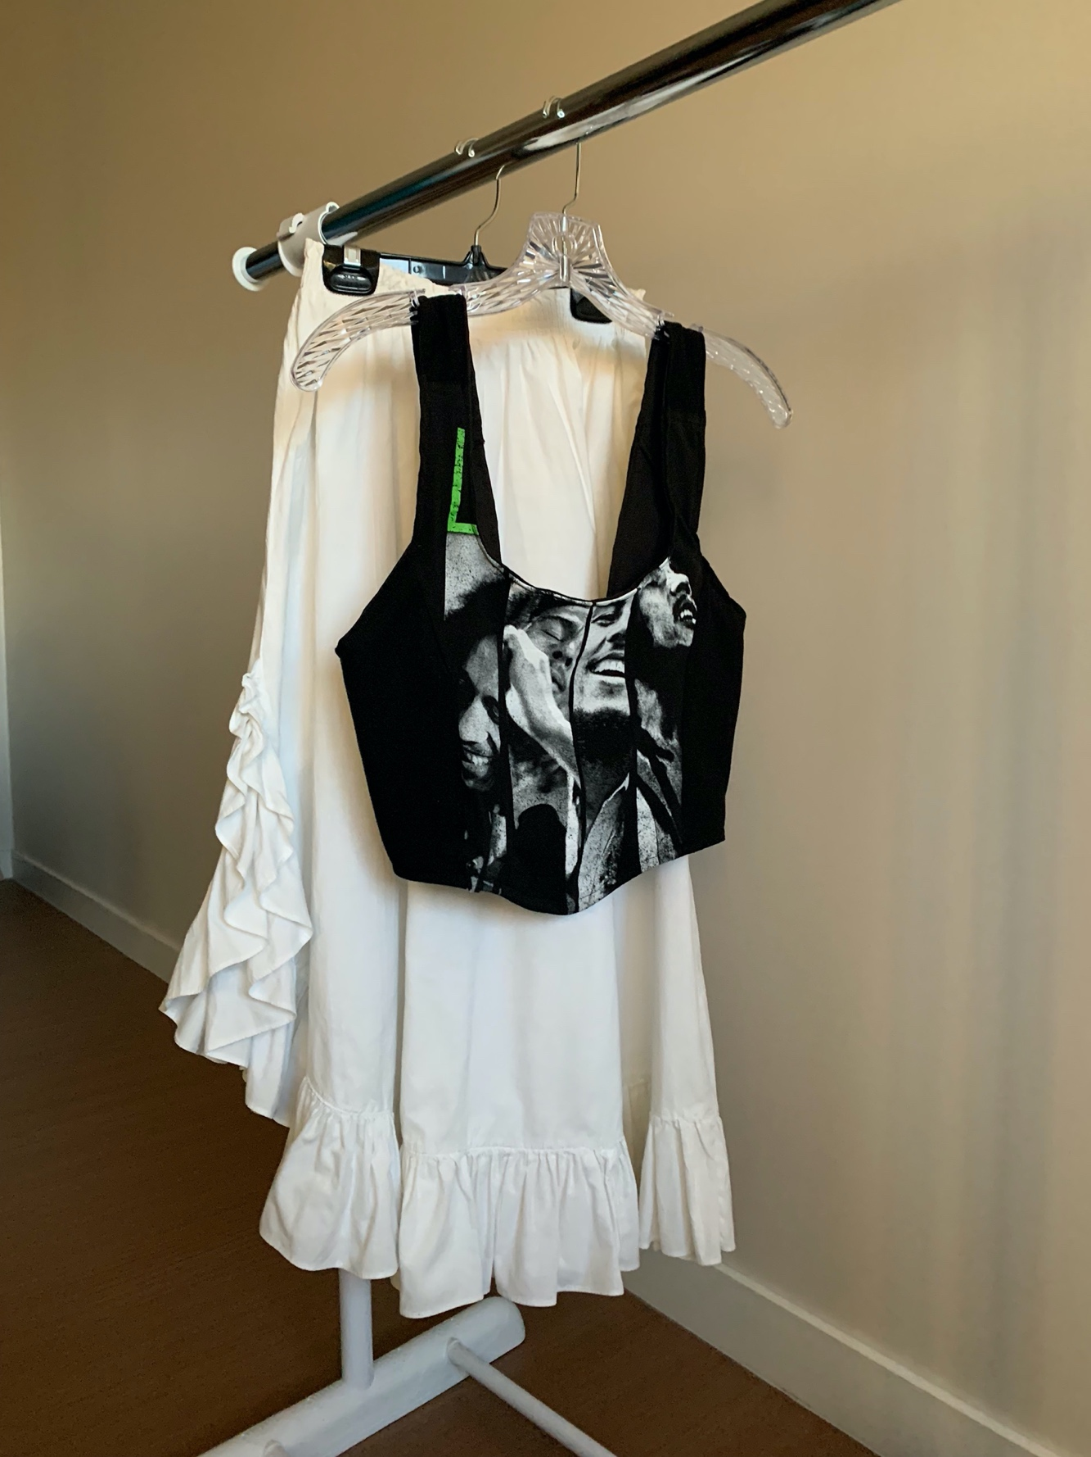
Grayson Chong, “Pon Di River: Corset and Skirt,” cotton, 2025.

